STANDARD FORMAT OF “LEHENGA DESCRIPTION”


For Online Selling Products
Design Name: CHIKUDI-B
Product Colours NO.: B1
. 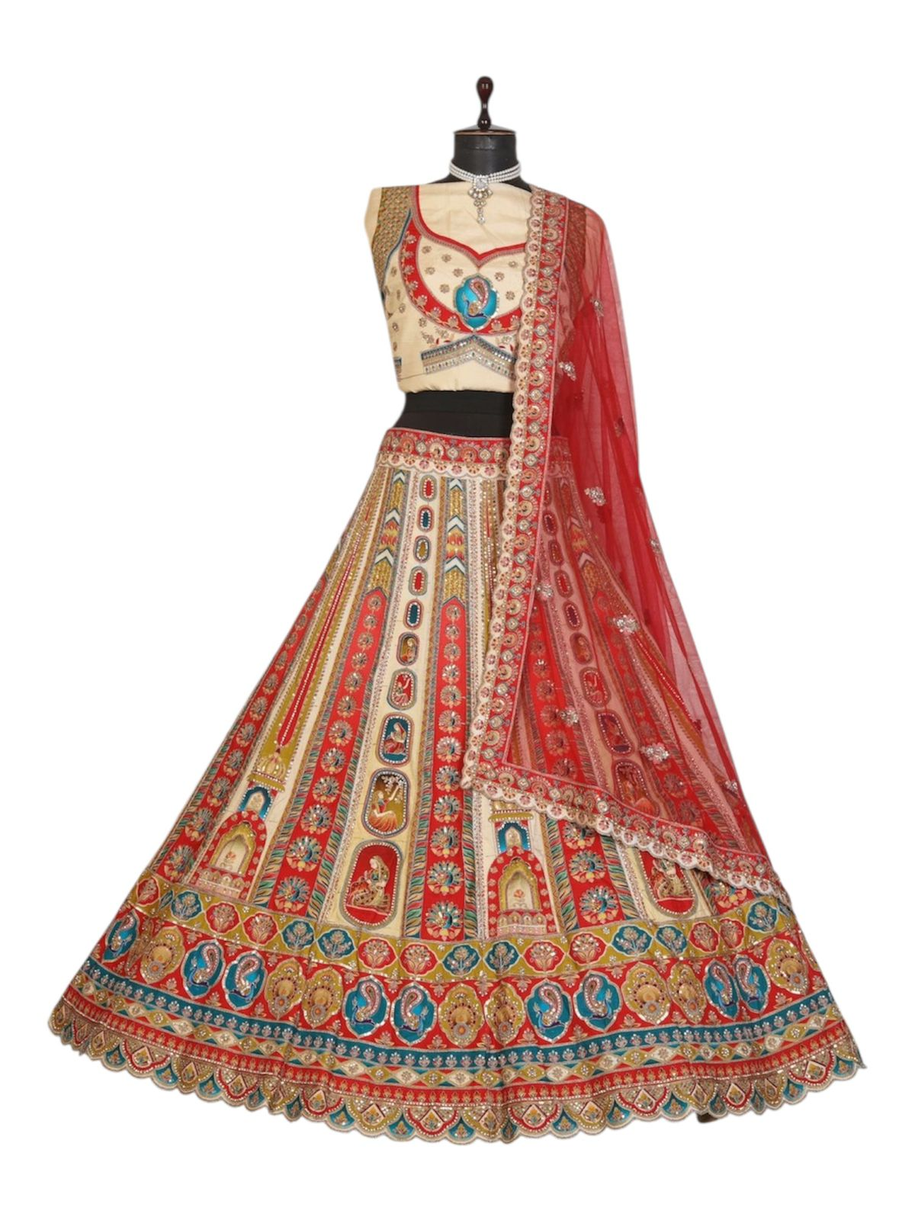
Particulars | Details
Lehenga Fabric | Position Printed Fabrics
Blouse Fabric | Position Printed
Dupatta Fabric | Net
Work Type | Jari, Jarkan
Colour | Chiku
Pattern | Gown Style Lehenga
Stitching Type | Semi-Stitched (Can be customized up to 44")
Occasion | Wedding, Reception, Engagement & Festive Wear
Fit Type | Regular Fit
Care Instructions | Dry Clean Only
Package Contents | 1 Lehenga, 1 Blouse Piece, 1 Dupatta

KEY HIGHLIGHTS
- Fashionable Gown-style lehenga for a modern festive look
- Made with soft Passion Print fabric for smooth movement
- Net dupatta adds an elegant, lightweight finishing touch
- Embellished with Jari–Jarkan work for festive shine
- Perfect for haldi, sangeet, reception & wedding functions
- Semi-stitched pattern ensures easy waist and length adjustments
- Designed for customers seeking a mix of style and comfort

